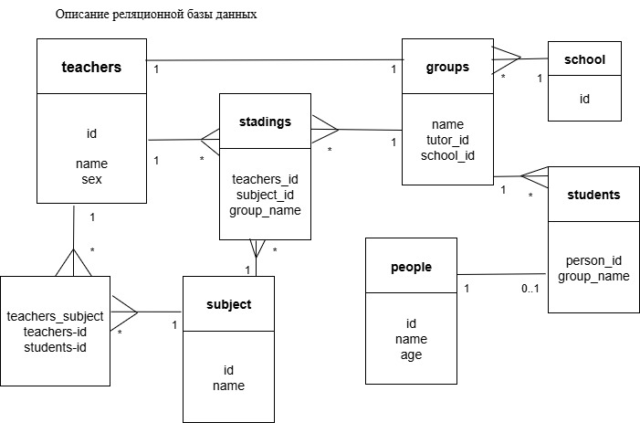

**Таблицы на языке SQL и работа с ними**

CREATE TABLE teachers (

id SERIAL PRIMARY KEY,

name TEXT NOT NULL

);

CREATE TABLE klasses (

name VARCHAR(64) PRIMARY KEY,

tutor_id BIGINT UNSIGNED NOT NULL,

FOREIGN KEY (tutor_id)

REFERENCES teachers (id)

ON DELETE CASCADE

);

CREATE TABLE students (

id SERIAL PRIMARY KEY,

name TEXT NOT NULL,

age SMALLINT NOT NULL,

klass_name VARCHAR(64) NOT NULL,

FOREIGN KEY (klass_name)

REFERENCES klasses (name)

ON DELETE CASCADE

);

CREATE TABLE subjects (

id SERIAL PRIMARY KEY,

name TEXT NOT NULL

);

CREATE TABLE study (

teacher_id BIGINT UNSIGNED NOT NULL,

subject_id BIGINT UNSIGNED NOT NULL,

klass_name VARCHAR(64) NOT NULL,

FOREIGN KEY (teacher_id)

REFERENCES teachers (id)

ON DELETE CASCADE,

FOREIGN KEY (subject_id)

REFERENCES subjects (id)

ON DELETE CASCADE,

FOREIGN KEY (klass_name)

REFERENCES klasses (name)

ON DELETE CASCADE,

PRIMARY KEY (teacher_id, subject_id, klass_name)

);

INSERT INTO teachers (name)

VALUES ('Иванов'), ('Сидоров'), ('Петров');

INSERT INTO klasses (name, tutor_id)

VALUES

('9К', 1),

('8Ж', 3);

INSERT INTO students (name, age, klass_name)

VALUES

('Иван', 15, '9К'),

('Петр', 16, '9К'),

('Олег', 14, '8Ж'),

('Анна', 14, '8Ж');

INSERT INTO subjects (name)

VALUES

('Математика'),

('Русский язык'),

('Информатика');

INSERT INTO study (teacher_id, subject_id, klass_name)

VALUES

(1, 2, '9К'),

(2, 3, '9К'),

(3, 1, '9К'),

(1, 2, '8Ж'),

(2, 1, '8Ж');

SELECT

s.name AS student_name,

k.name AS klass_name,

t.name AS tutor_name

FROM students AS s

LEFT JOIN klasses AS k

ON s.klass_name = k.name

LEFT JOIN teachers AS t

ON k.tutor_id = t.id;

SELECT * FROM teachers;

SELECT * FROM students;

SELECT * FROM study;

DELETE FROM klasses WHERE name = '9К';

SELECT * FROM teachers;

SELECT * FROM students;

SELECT * FROM study;

EXPLAIN SELECT * FROM study;

